Data Sheet for “Electrical Circuits”

Section _____ Partner’s Last Name ____________________ Your Name __________________

Part A: A Simple Circuit

1. Set up the circuit shown in Figure 11-A, using the 3V battery, the first bulb of the three-bulb board, and 2 wires. On Figure 11-A, draw red arrows showing the direction of the current when the switch is on. Draw black arrows showing the direction of electron flow. Turn on the switch. What is observed? ____________________________
With the switch still on, loosen the bulb. What is observed? ______________________
Why? _________________________________________________________________
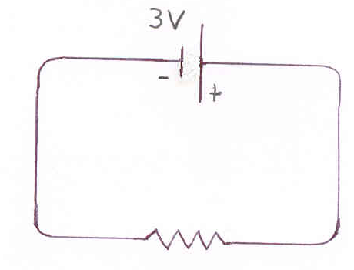
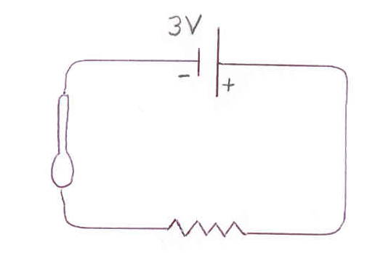

Figure 11-A Figure 11- B

2. Tighten the bulb (not too tight). Turn off the switch. Use another wire to set up the circuit shown in Figure 11-B, where a metal spoon is made part of the circuit.
Turn on the switch. What is observed? __________________________________
Is the metal spoon a conductor, or an insulator? ____________________________

Turn off the switch and replace the metal spoon with the plastic spoon.
Turn on the switch. What is observed? __________________________________
Is the plastic spoon a conductor, or an insulator? ____________________________
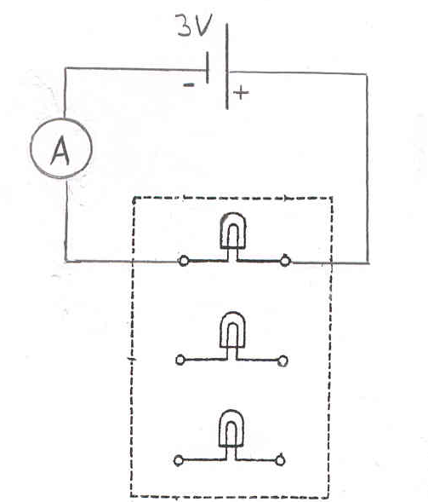
- Turn off the switch, remove the plastic spoon,
and connect the ammeter in its place as shown
in the figure to the right. _-

Turn on the switch and measure and record the current to the nearest 0.01 A. _________
Turn off the switch. Disconnect the ammeter, and replace it with one wire, as previously. Connect the ammeter between the positive terminal of the battery and the bulb. Check to see that the positive connection on the ammeter is toward the positive side of the battery.
Turn on the switch and measure and record the current to the nearest 0.01A. _________
Was the current the same (within experimental error) on both sides of the circuit?______
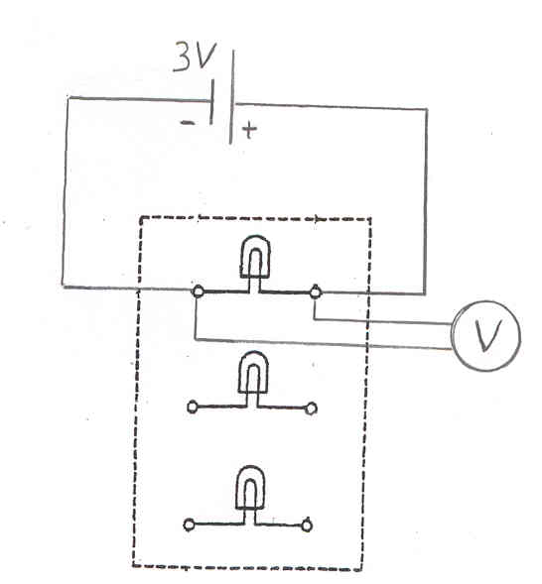
- Turn off the switch, disconnect the ammeter,
and again use one wire to connect the positive
terminal of the battery to the bulb. Connect a
wire to the common input of the voltmeter and
a wire to its middle input, where the scale will
read 0 to 3 V.

Turn on the switch. Touch the voltmeter’s red connection (+) to the positive side of the bulb and the black connection (-) to the negative side of the bulb as shown in the figure above. This measures the voltage across the bulb. Read the voltage, to the nearest 0.05V, on the scale that goes from 0 to 3V. _______

In similar fashion, being careful to touch the correct leads to the proper places, measure the voltage across the battery and then turn off the switch. _______

Use the value of the current from Part A.3 and of the voltage across the bulb, along with Ohm’s law, to calculate the resistance of the bulb.

Setup: Answer: _____________

Use P = IV to find the power used by the bulb.

Setup: Answer: _____________

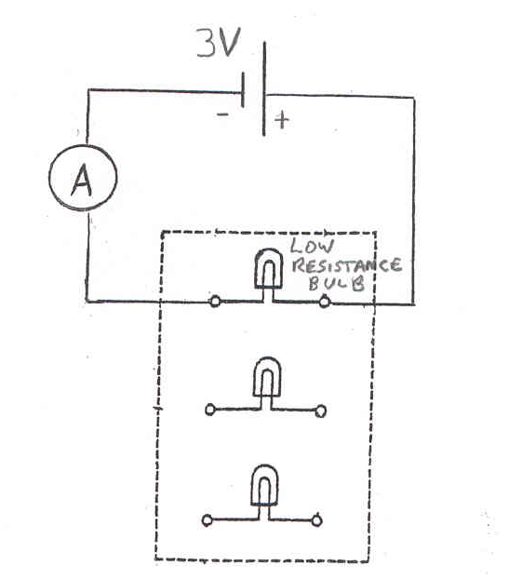
Part B: The Effect on Current of Changes in Voltage and Resistance

- Use the same setup as in A.3,
with the ammeter in the circuit. Turn
on the switch and note the brightness of the bulb.

Turn off the switch and replace the regular bulb
with one that has lower resistance as shown in
the figure on the right.

Before turning on the switch, use Ohm’s law (I = V/R) to predict what will happen to the current (I) in the circuit when the battery voltage (V) stays the same, and the bulb resistance (R) is decreased. ________________ (larger/smaller/same)

An increase in current will cause a brighter bulb; a decrease in current will cause a dimmer bulb. According to your prediction of the change in current, should this bulb be brighter, or dimmer, than the first bulb? ________________

Now, turn on the switch. Results? Current value: ______ Brightness: _____________
Were the changes in current and brightness of the bulb consistent with Ohm’s law? _____________ (yes/no)

Turn off the switch and replace the low resistance bulb with the original bulb.

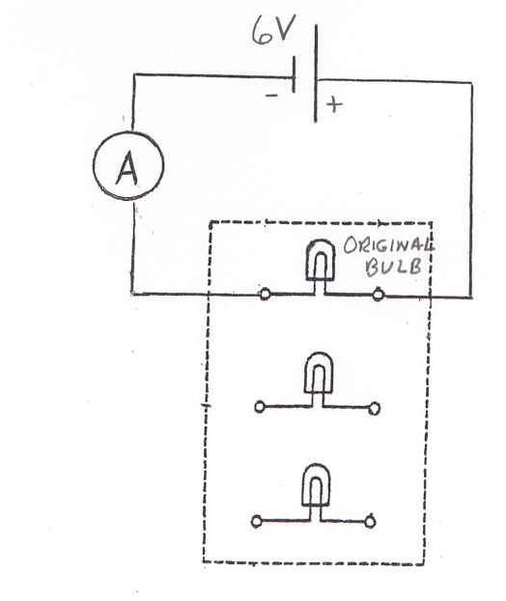
2. Change the voltage from 3V to 6V. Keep the ammeter connected as shown in the figure below. According to Ohm’s law,
if the resistance stays the same and
the voltage increases, what
should happen to the current?
___________________________
(larger/smaller/same)

Therefore, what should happen to
the brightness of the bulb?
_____________________
(brighter/dimmer/same)

Turn on the switch. What is the value for the current? ______________________
Is the bulb brighter or dimmer, with the 6 V than with the 3 V source? _______________

Carefully use the voltmeter to measure the voltage across the bulb. Be sure the black connection on the voltmeter is connected to the side of the bulb connected to the negative side of the battery. Voltage:__________________

Turn off the switch. Use Ohm’s law to find the bulb’s resistance when this voltage is used.
Setup: Answer: _________

Is the bulb’s resistance still the same as found in Part A.4 where 3 V were used? ________ (yes/no). Ohmic resistors have constant resistance for any current.
Therefore, is a light bulb an ohmic, or a non-ohmic, resistance? ____________

Use P = IV to find the power now used by the bulb.

Setup: Answer: _________
Part C: A Series Circuit
Note: Be sure to switch the voltage back to 3 V!
1. Set up the bulb board, the 3 V battery, and the ammeter so that two regular bulbs are connected in series as shown in the figure below. In the space at the right, sketch a schematic of the circuit using the shorthand notation shown on page 129 of the lab manual.
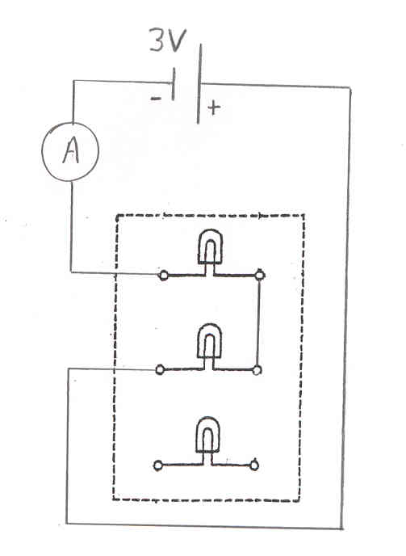

Get the instructor’s approval (initials) here before turning on the switch. ________

Turn on the switch. Are the bulbs equally bright? _________________________
Are they brighter, or dimmer, than when only one regular bulb was in the circuit?
____________
What does the brightness indicate about the current through each bulb? _________________________________________________________________
What is the value given by the ammeter for the current through the two bulbs in series? _________
Is the current less than in Part A.3, where only one bulb was used? _________

2. Turn off the switch. Connect all three bulbs in series.
Before turning on the switch, predict if all the bulbs will be of equal brightness. ________ (yes/no)
Will they be brighter, dimmer, or the same as when two bulbs were in the circuit? _________
Now, turn on the switch and test your brightness predictions. Results? ______________
What does this indicate about the current through the bulbs? _______________________
What is the value given by the ammeter for the current for three bulbs in series? _________

Is that less than the current when only two bulbs were in series? ___________________
With the switch still on, loosen one of the bulbs. What happens, and why? ___________
________________________________________________________________________
Retighten the bulb and turn off the switch.
Part D: A Parallel Circuit

1. Set up the bulb board, the 3V battery, and the ammeter, so that two bulbs are connected in parallel as shown in the figure below. In the space at the right, sketch a schematic of the circuit using the shorthand notation shown on page 129.
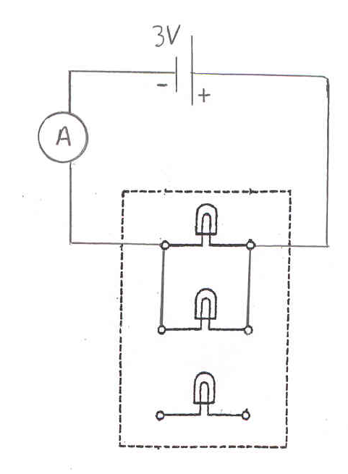

Get the instructor’s approval (initials) here before turning on the switch. _____________

According to the reading assignment in the lab manual, should the current through each of the two bulbs be greater, or less, than when the two were in series? __________

Turn on the switch. Are the bulbs equally bright? ________________________
Are the bulbs brighter, or dimmer, than when the two bulbs were in series? ___________
What does the brightness indicate about the current through each bulb? ______________
What is the value for the total current, as given by the ammeter? ____________________
Is this less, more, or the same as when two bulbs were in series (see Part C.1)? ________
Is this less, more, or the same as when only one bulb was used (see Part A.3)?_________
Do two bulbs in parallel really allow more current than just one bulb by itself?_________
Turn off the switch.
Connect the ammeter to measure the current through one bulb as shown in the figure below. Turn on the switch and measure the current then turn off the switch.
What is the current? ____________

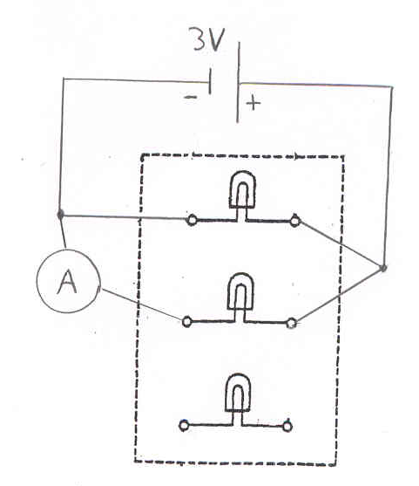

Connect the ammeter to measure the current through the other bulb as shown in the figure below. Repeat the current measurement. What is the current? __________________

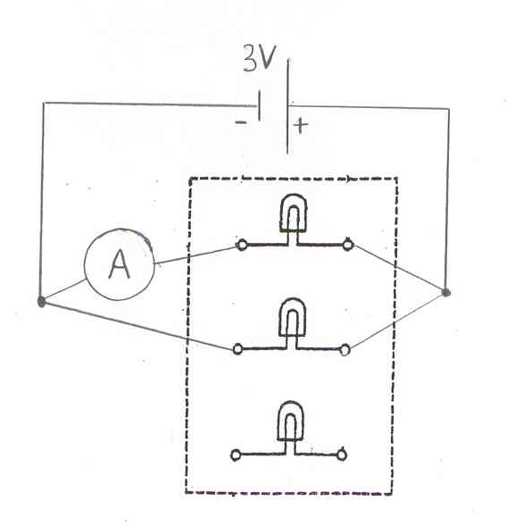

Do the last two current values add up to the total current (allowing for experimental error)? ____________

2. Turn off the switch. Connect all three bulbs in parallel. Before turning on the switch, predict whether all the bulbs will be of equal brightness. Will they be brighter, or dimmer, than when only two bulbs were in the circuit? ________________________

Turn on the switch and test your brightness predictions. Results? __________________
What does this indicate about the current through the bulbs? _______________________

What is the value for the current, as given by the ammeter? ______________________

With the switch still on, loosen one of the bulbs. What happens, and why? ________________________________________________________________________

Turn off the switch, and then disconnect all wires and meters.

